Wireshark – Analyzing FTP

On Linux I need to get a liberay to start a ftp server for this I will get this - <https://github.com/giampaolo/pyftpdlib>

Starting a FTP server first I had to get ot the temporary folder for the **cd /tmp/ftpserver** then run the command **Python -m pyftplib -p 21 -w**

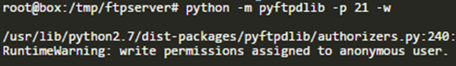

Connectiong to the ftp is straight forward and easy because all you need to do is use the command if you have the package installed in linux is ftp followed by the IP address, you could also connect to the server using tools such as filezilla. Here is the cli dump from download a text file called test.txt this can also be uploaded using the put command.

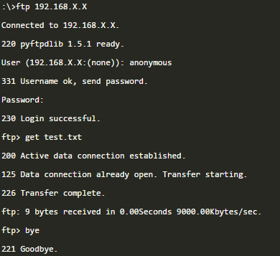

Here is the wireshark capture of the ftp communication between myself and my ftp server

